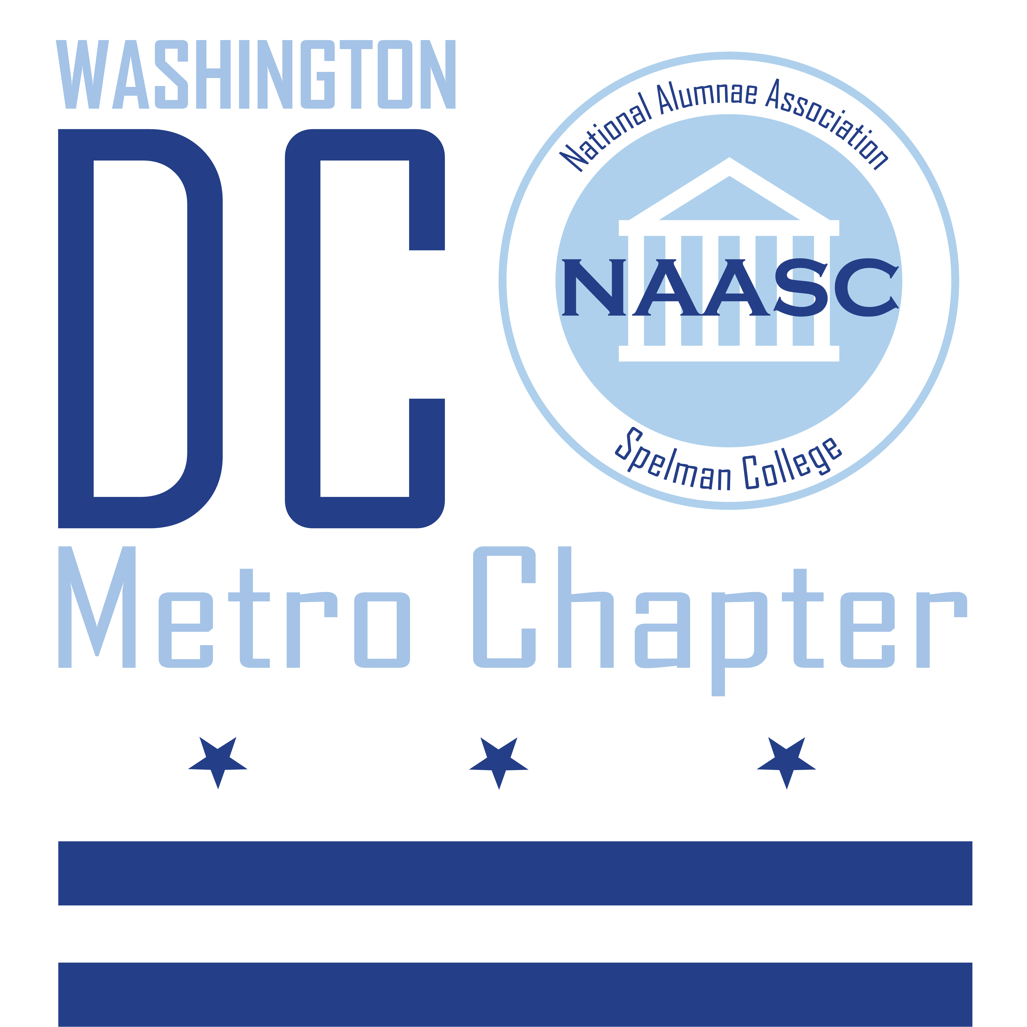

About Us
The National Alumnae Association of Spelman College (NAASC) is the official organization that supports Spelman College, a historically black college for women, through financial gifts, student recruitment, sisterhood, community service, and recognition of Spelman women. One of many chapters worldwide, the DC Metro area lovingly serves communities in the Washington, DC, Northern Virginia counties, and some southern Maryland counties. The Association provides, encourages, and promotes growth and development of alumnae through leadership opportunities and partnership alliances. NAASC actively seeks to involve all former students and graduates in the fulfillment of its purpose.

The Scholarship Program
The NAASC DC Metro chapter offers non-renewable awards of varying amounts. Students meeting all the criteria below will be considered for one of the following awards. All submitted applications will be accepted as long as they are in compliance with the award posted deadline and criteria.

• NAASC DC Metro Technology and Book Award - Given the events of 2020 a new award is being offered to specifically address the new technology needs imposed on students due to the impact of COVID-19 and distance learning.
• Golden Girl Book Awards

Criteria for 2020 NAASC-DC Awards:
• Student must be an incoming first-year student at Spelman College
• Student must be a resident of Washington, DC, Northern Virginia counties, and some southern Maryland counties.
• Student must complete and submit the online application by July 10, 2020, 11:59 pm EST. Access by clicking this 2020 Scholarship Application link
• The online application includes an essay question that is to be answered in 300-500 words.
• Minimum GPA of 3.0
• Awards will be made on the basis of the following:
o Fully completed application submitted by deadline
o Quality and creativeness of the essay
o Scope and impact of Community Service
o Overall adherence to the award instructions
• Award payment will be made upon receipt of proof of enrollment (i.e. first-semester course schedule). Email proof of enrollment to the Scholarship Committee at scholarships@naascwdc.org.

Award Notification
• All award recipients will be notified by August 7, 2020.

